# CS 340 README Template

*Use this template to complete your README file. When completing the template, keep the headings as they are so that your document has a clear organization. Remove the italicized prompt text after you have completed each section for a polished final document.*

## About the Project/Project Title

*CRUD is the title of this project it was made to create, read, update, and delete items in a mongo database, thus its’ name CRUD.*

## Motivation

*My motivation for producing and maintaining this project is to fulfill the needs of assignments from my CS 340 class.*

## Getting Started

*First you should make sure you have a mongo database you want to work on. If you do not have a database you can upload one from a CSV file(Screen Shot 1). Once you have a database, you need to make a new user for that database. This user should only be able to access and update databases you assign to them(Screen Shot 2). Once you have created a new user, you should try signing into mongosh with the new user(Screen Shot 3). Use the show command to see what databases the new user can see. Only the databases you gave them access to should appear(Screen Shot 4).*

*The module create function works by first checking to see if anything was passed to it, if not it does nothing. If you pass a dictionary to the function it will insert that dictionary into the database. The read function works by passing the input value to the find function, and return the results.*

*find out what port you use to access the database, along with your host. Finally you should check to make sure your username and password allow you to access the database. You should enter your database name, port, and host into the module in place of the values for HOST, PORT, and DB. Once these steps are complete, you can use the module to insert values and find values in the database.*

Note: I am placing red outlines around commands, and blue outlines around execution.

*Screen Shot 1:*

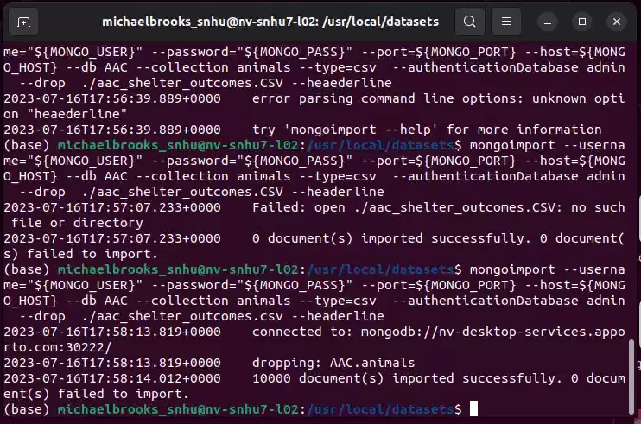

*Screen Shot 2:*

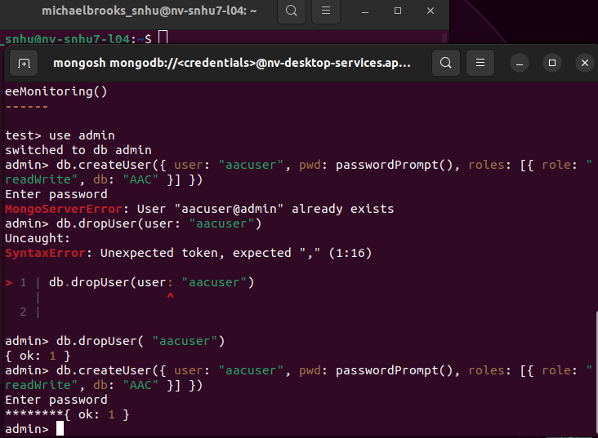

*Screen Shot 3:*

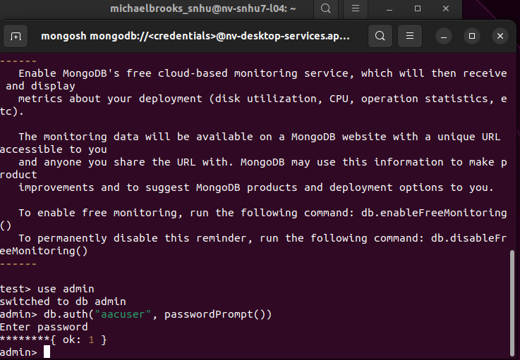

*Screen Shot 4:*

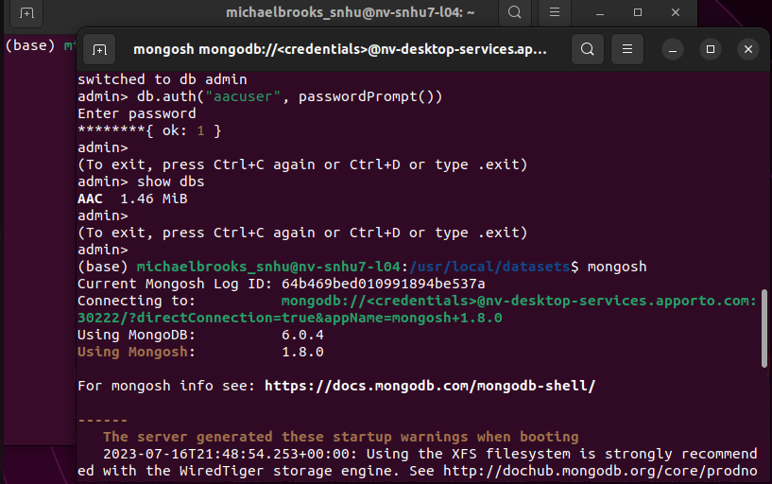

## Installation

*You will need Mongo, Jupyter notebook, as well as the pymongo and bson.objectid libraries. To install mongo you should follow this* [*guide*](https://www.mongodb.com/docs/manual/tutorial/install-mongodb-on-windows/)*. You can install Jupyter notebook with this* [*guide*](https://jupyter.org/install)*, you can install pymongo with this* [*guide*](https://medium.com/@pragya_paudyal/connecting-mongodb-to-jupyter-notebook-e3f636a85830#:~:text=Open%20a%20jupyter%20notebook%20and,we%20need%20to%20create%20MongoClient.)*, and finally, you should be able to install bson with a similar command to the one listed in the pymongo guide. Once the software is set up you can establish your database, and from there you should adjust the variables mentioned above so you can access your new database.*

## Usage

*this project allows the user to work with and manipulate a mongo database using python. It could also be implemented as the back end of a database management app. Using buttons or windows instead of command lines would allow users who are not familiar or comfortable with command prompts to also work in a mongo database. When first using this module, I recommend working in a duplicate database. You should probably do this until you have a good handle on what each function does, and how they work. I recommend this so you do not damage your original database. Additionally, I recommend you be careful with your peramiters. As each function is designed to work on single entries as well as multiple entries and no entries. This means a line like deleted = CRUD.delete() could delete your entire database, so be very careful.*

### Code Example

*self.client = MongoClient('mongodb://%s:%s@%s:%d' % (USER,PASS,HOST,PORT))*

*self.database = self.client['%s' % (DB)]*

*self.collection = self.database['%s' % (COL)]*

*print("Connected Successully.")*

*These lines of code are from the MongoClient library, and are used to connect to the specified Mongo database.*

### Tests

*If the lines of code above are executed successfully, then the module outputs a message saying it was able to connect, if the module does not connect, and there is an error, the message will not be output. The first screen shot shows a successful connection, while the second one shows the errors that occur from an unsuccessful connection*

### Screenshots

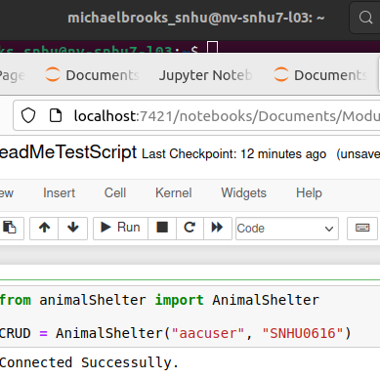

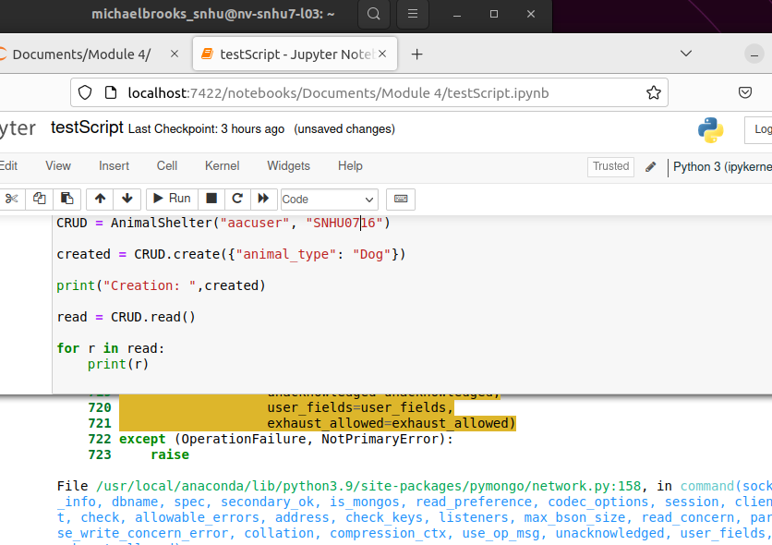

*Below you will find examples of each command in the CRUD method being executed. Each screen shot will be preceded by a label that also explains what each colored box contains. Each screen shot may be followed by additional comments to further explain the test code.*

***C create****: The red box contains the test code, while the blue box contains the output of that code.*

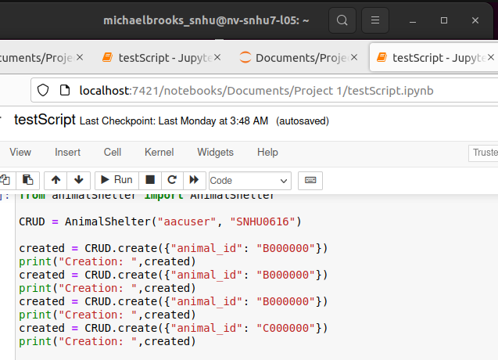

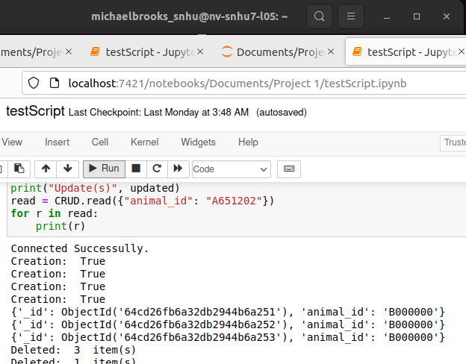

*The create function returns true if t he item was successfully created, Proof that the item was created will be displayed in the read section of the test.*

***R read****: The red box contains the test code, while the blue box contains the output of that code.*

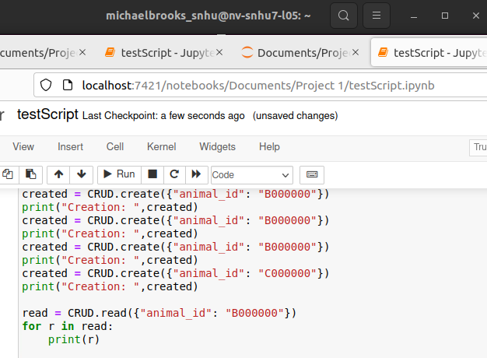

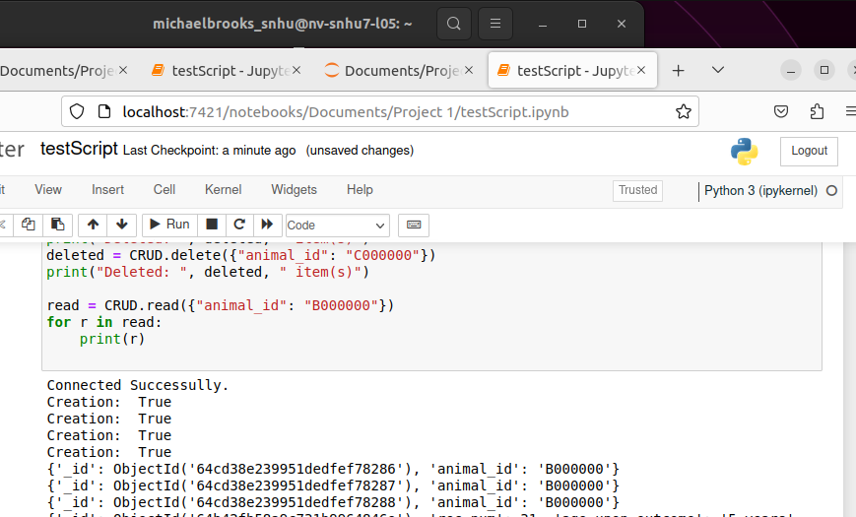

*As you can see in the red box, three items were created with the animal_id of B000000, and when the read function searched for that animal id, it returned three matches.*

***U update****: The red box contains the test code, while the blue box shows the initial output for the selected data set, and the green box shows the updated output(s). The yellow box will highlight the changes between entries, and the object ids will be outlined in purple.*

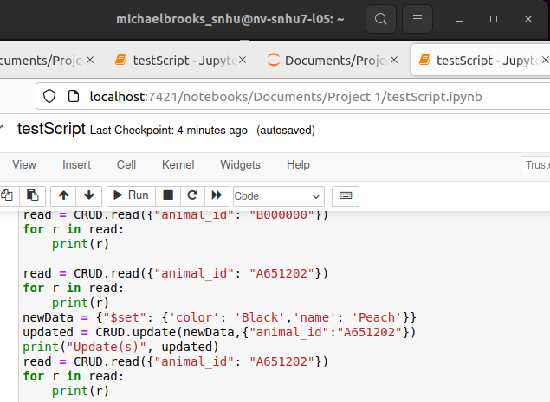

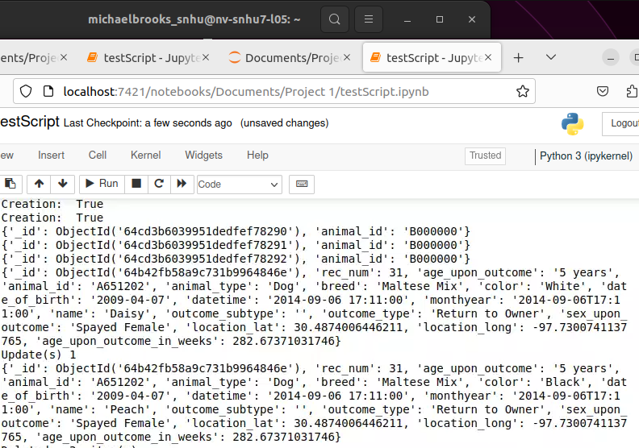

*As you can see, Daisy was changed to Peach, and White changed to Black. This function can update a single entry or multiple entries, and you can make multiple changes at a time.*

***D delete****: The red box shows the test code, while the blue box shows the output of the code.*

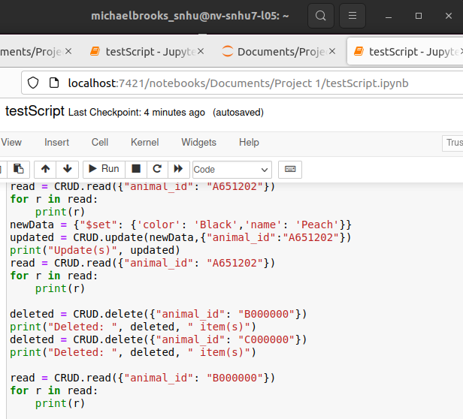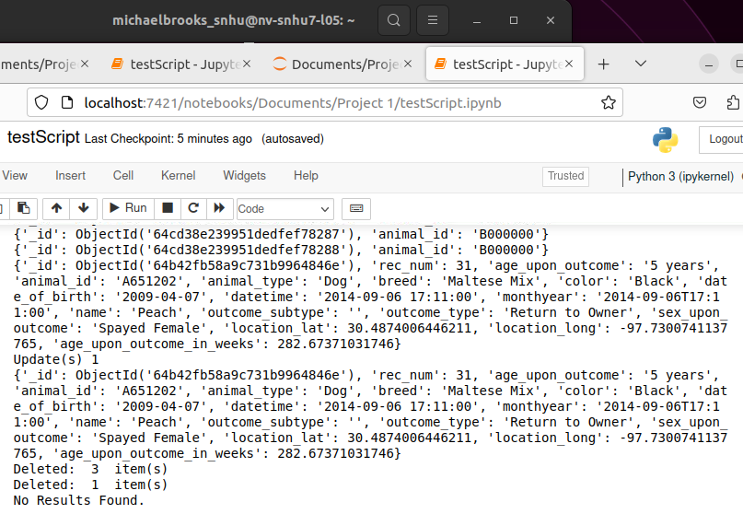

*The delete function can delete entries based on the given data. If you want to delete a specific entry, I recommend using the object’s id as the data, as the delete function can delete a single entry, or multiple entries depending on the data used.*

## Contact

Michael Brooks: